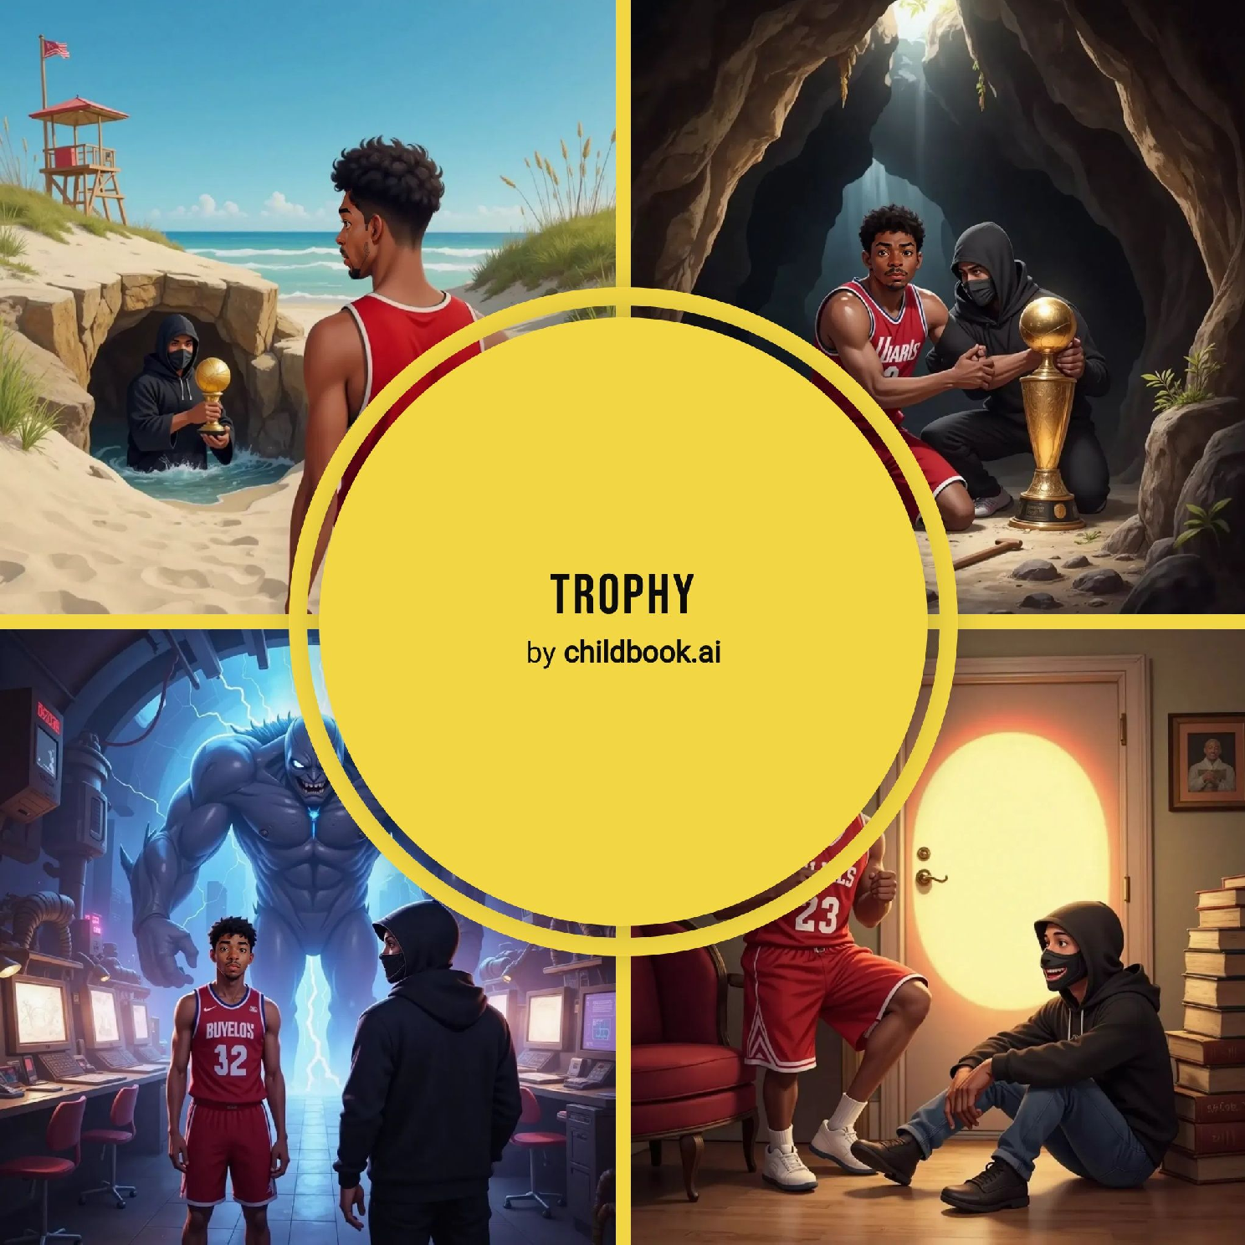

Michael Jordan bounced his ball along the beach. Suddenly, a robber dashed by holding his shiny NBA trophy! “Hey! That’s mine!” shouted Michael. The robber raced toward a rocky trapdoor. Michael threw his basketball but missed. He chased after, determined not to lose his prize.

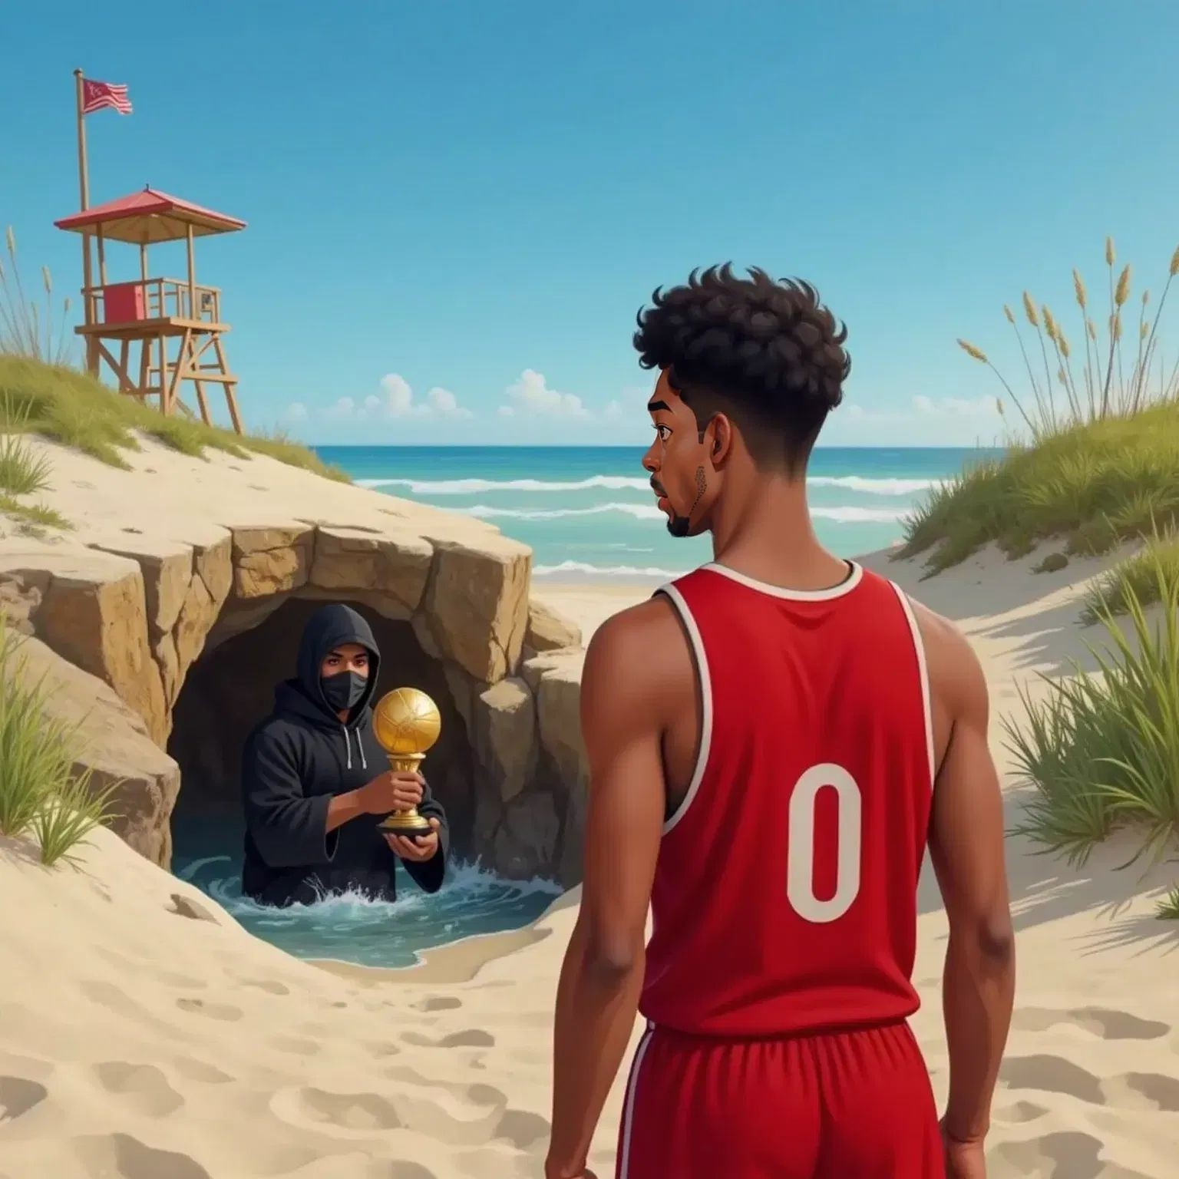

The robber dove through the trapdoor with Michael close behind. They lost their balance and tumbled into darkness, landing with a thud. "Ouch!" groaned Michael. He grabbed the robber, who squeaked, "AAAAAA!" Michael asked, “Why steal my trophy?!” The robber replied, “Sorry, I just wanted to impress my friends.”

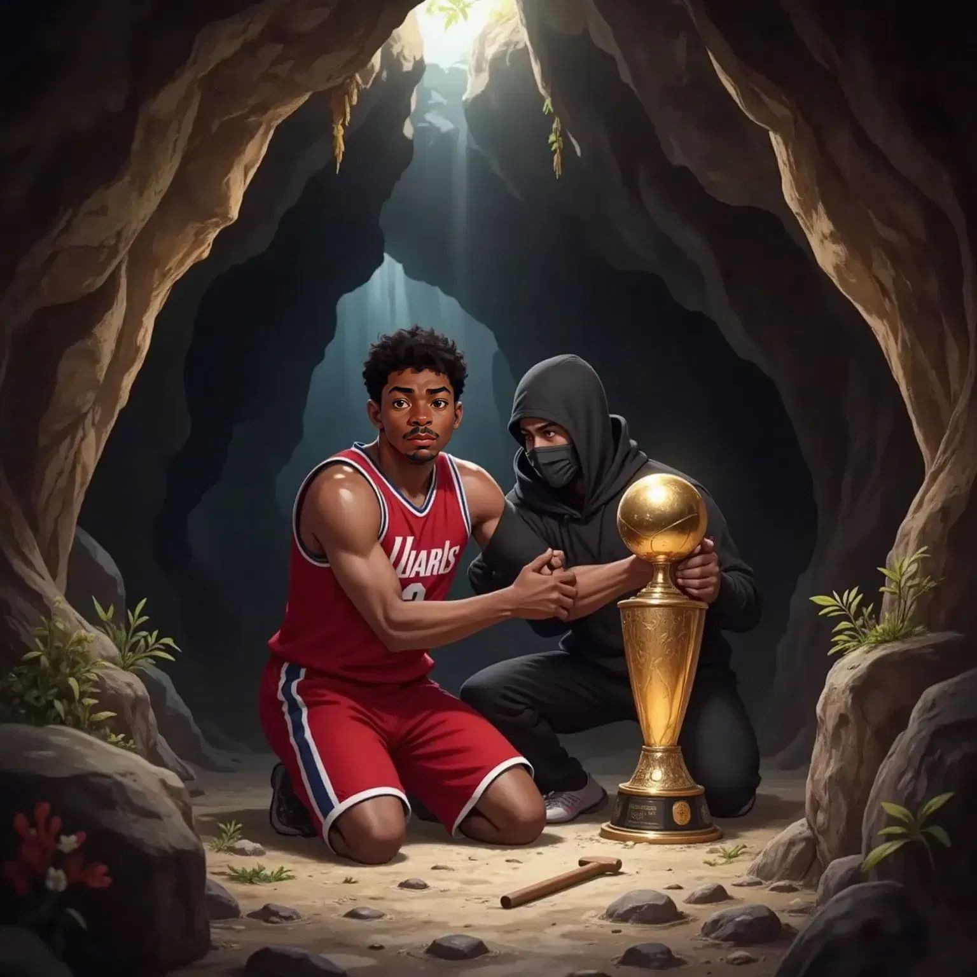

They looked around the strange, glowing room. “What is this place?” wondered Michael. The robber said, “A portal storage room… I think.” Suddenly, a loud growl echoed. A huge monster appeared! “Run!” yelled Michael, grabbing the robber’s hand. Together they ran as fast as they could.

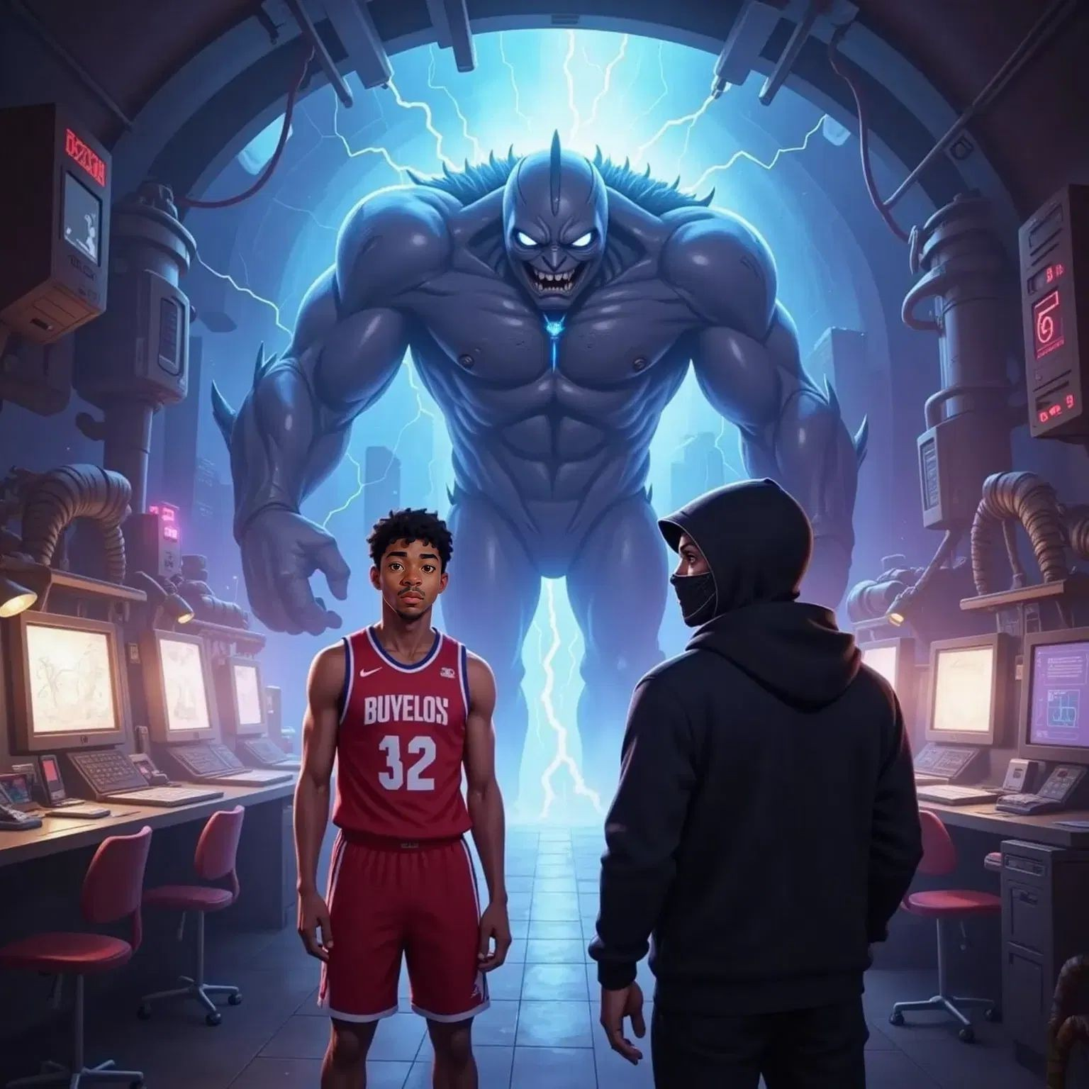

The robber accidentally ran into a wall and fainted! The monster disappeared with a funny 'beep'—it was just a hologram. Michael laughed, “Let’s find a way out together.” The robber woke up dizzy but smiled. They spotted a friendly, glowing portal. Hand in hand, they jumped through and cheered, “Adventure complete!”

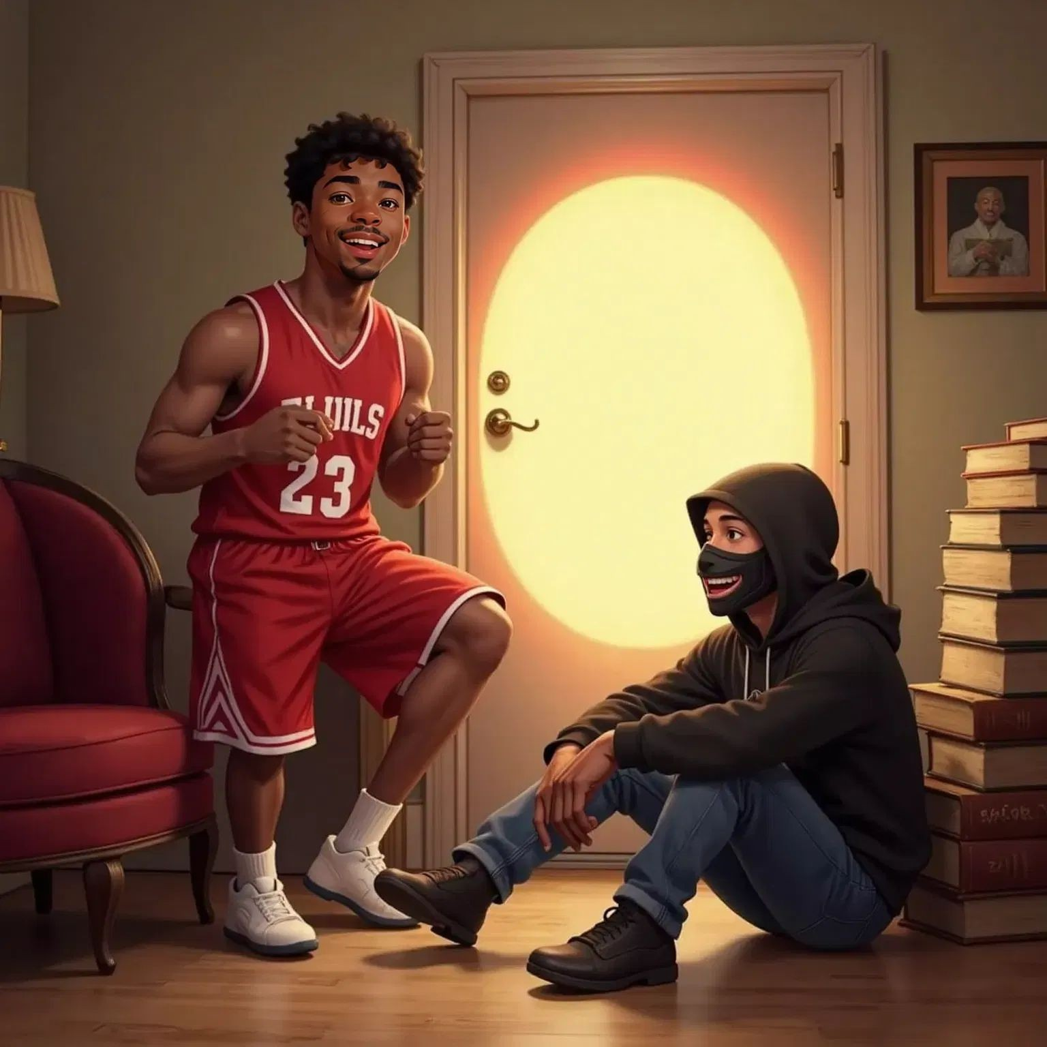

SPARK YOUR CHILD's IMAGINATION

AND CREATE PERsONALIZED CHILDREN's BOOKs WITH CHILDBOOK.AI!

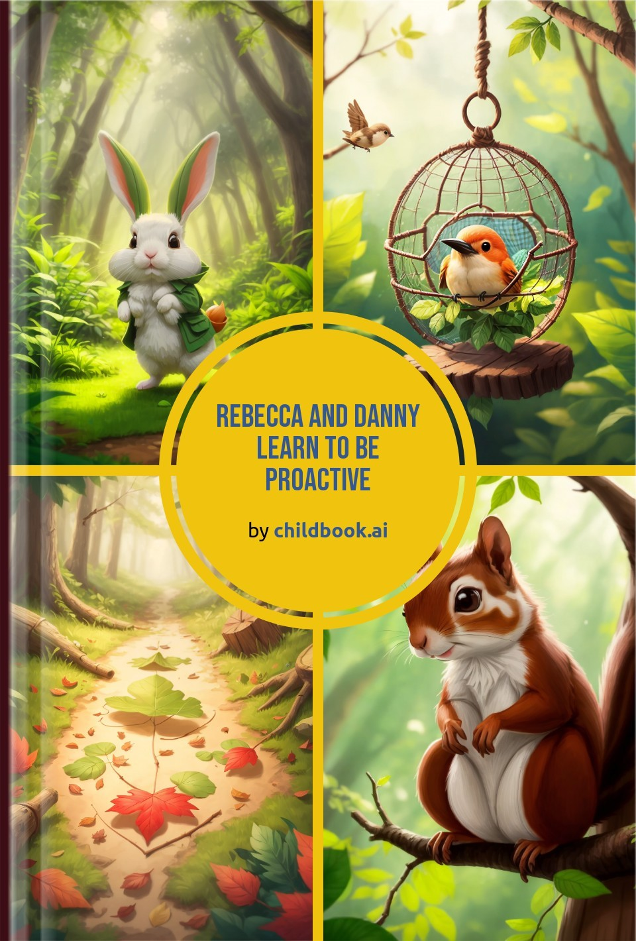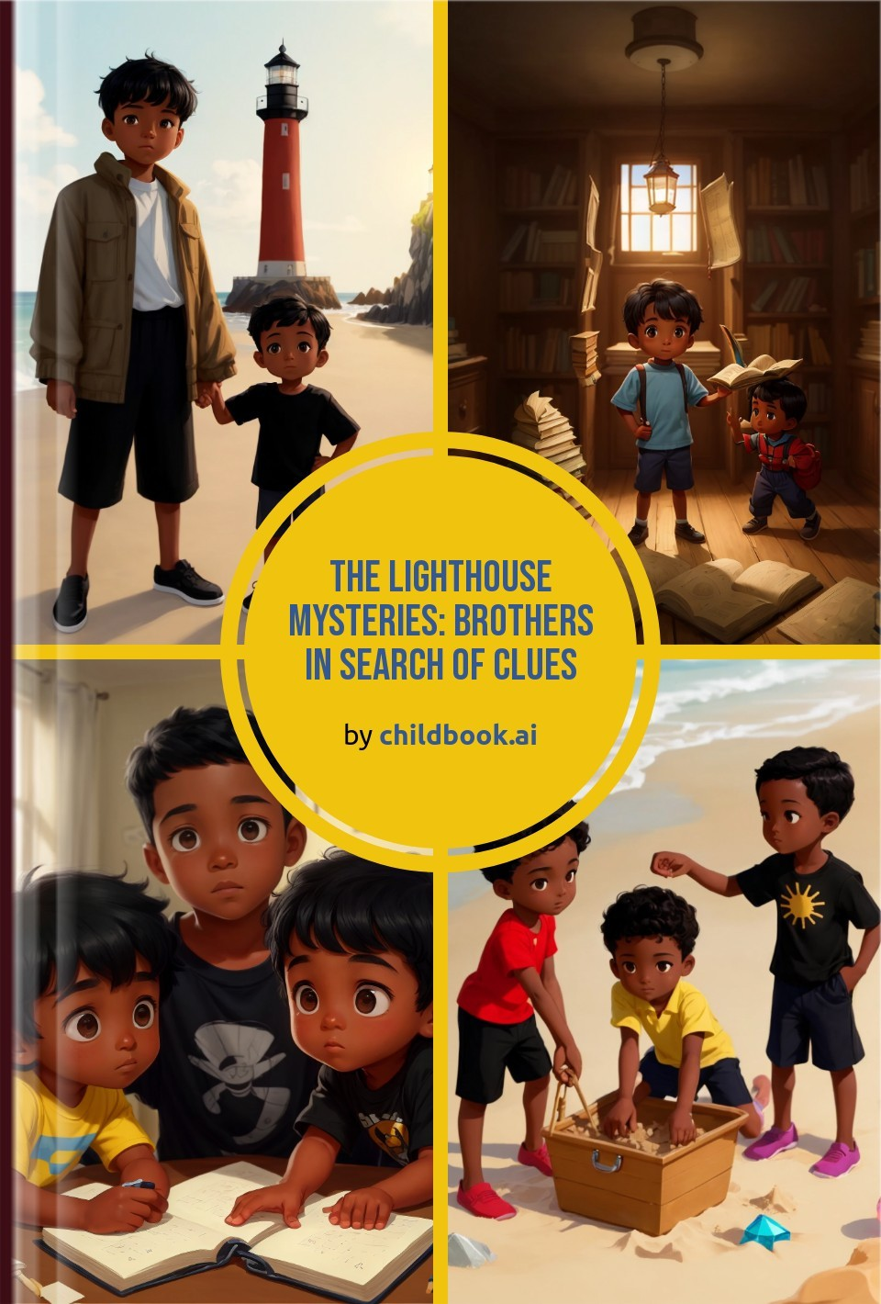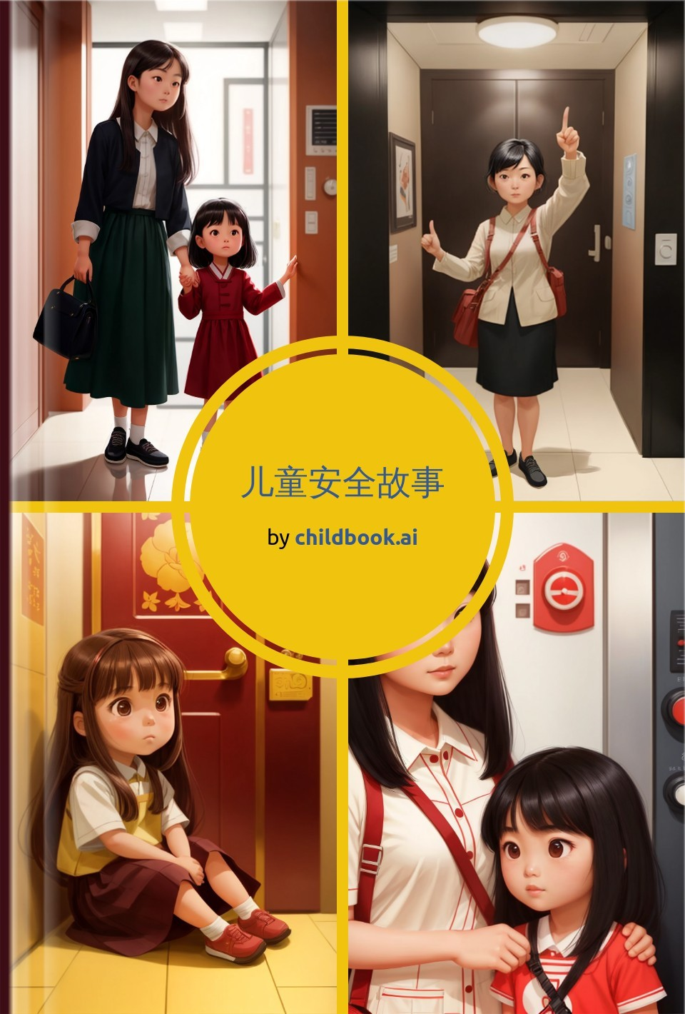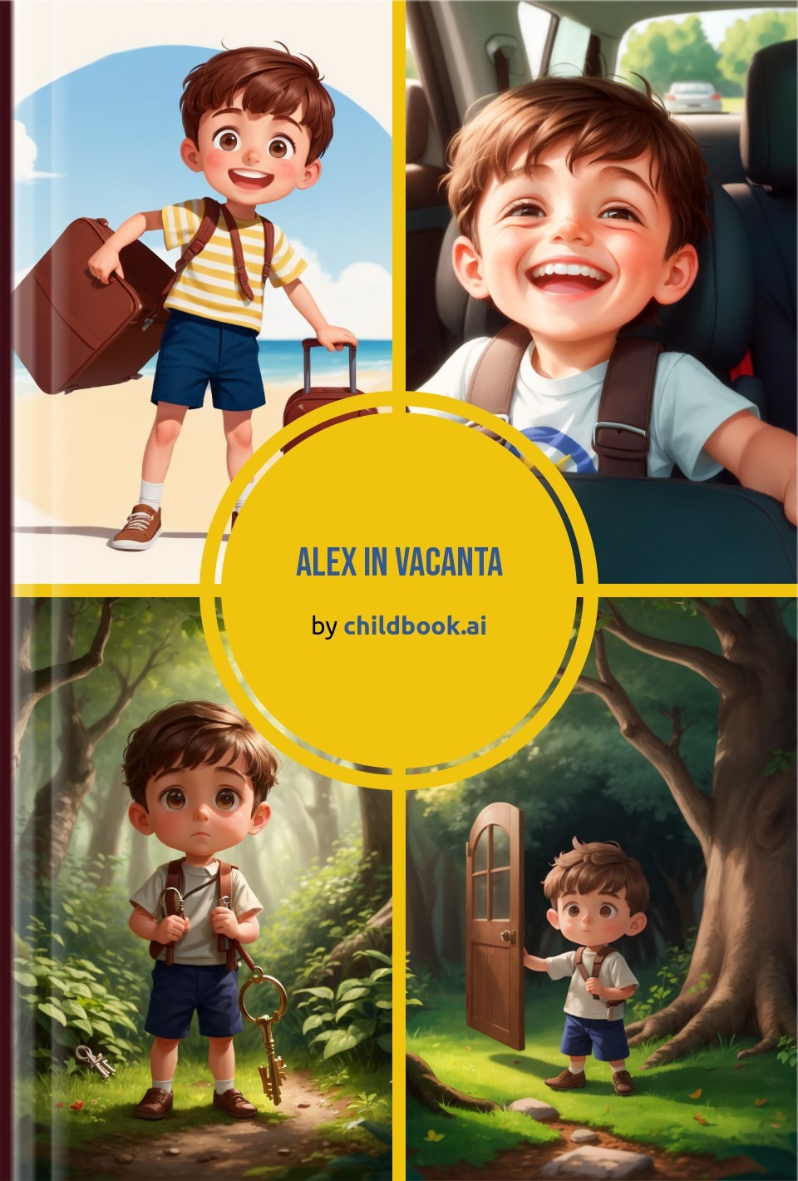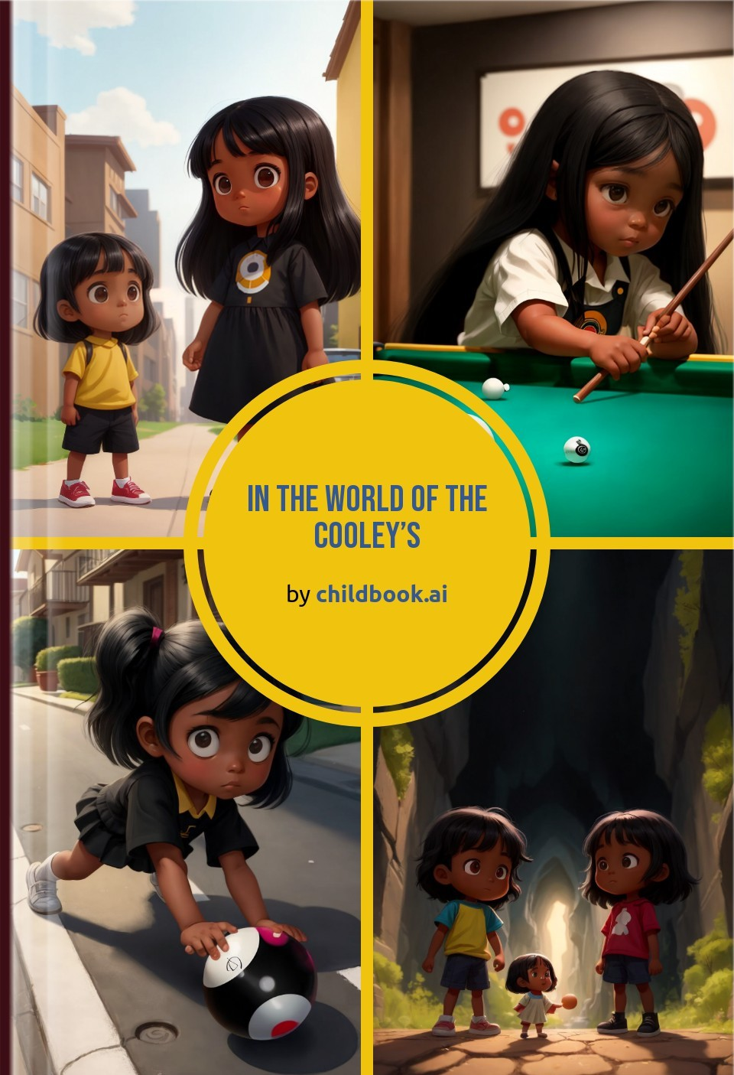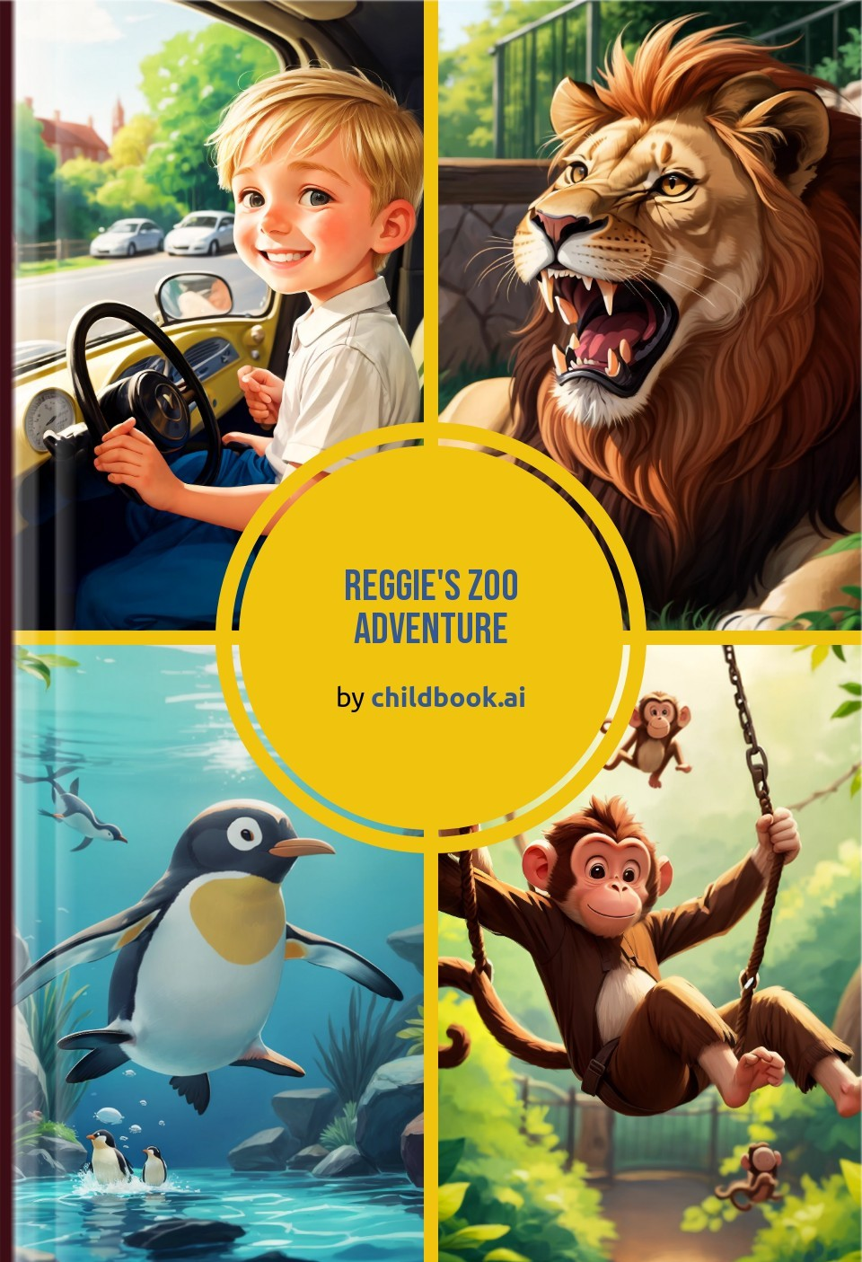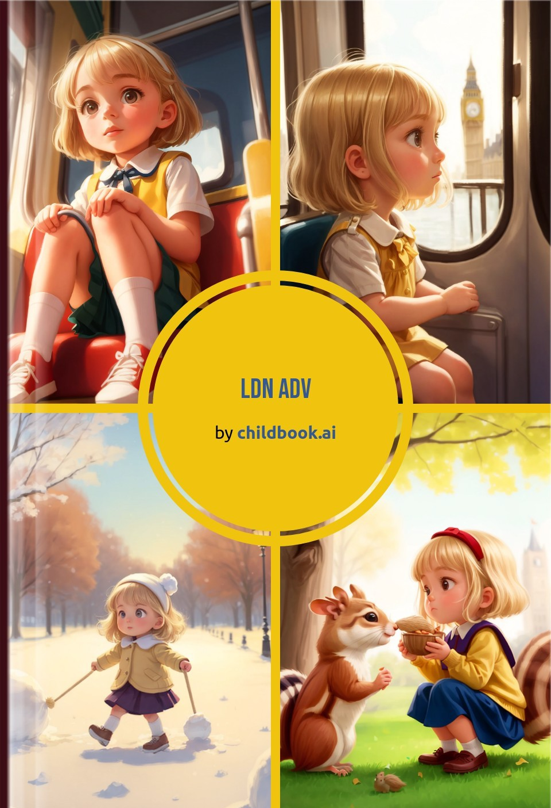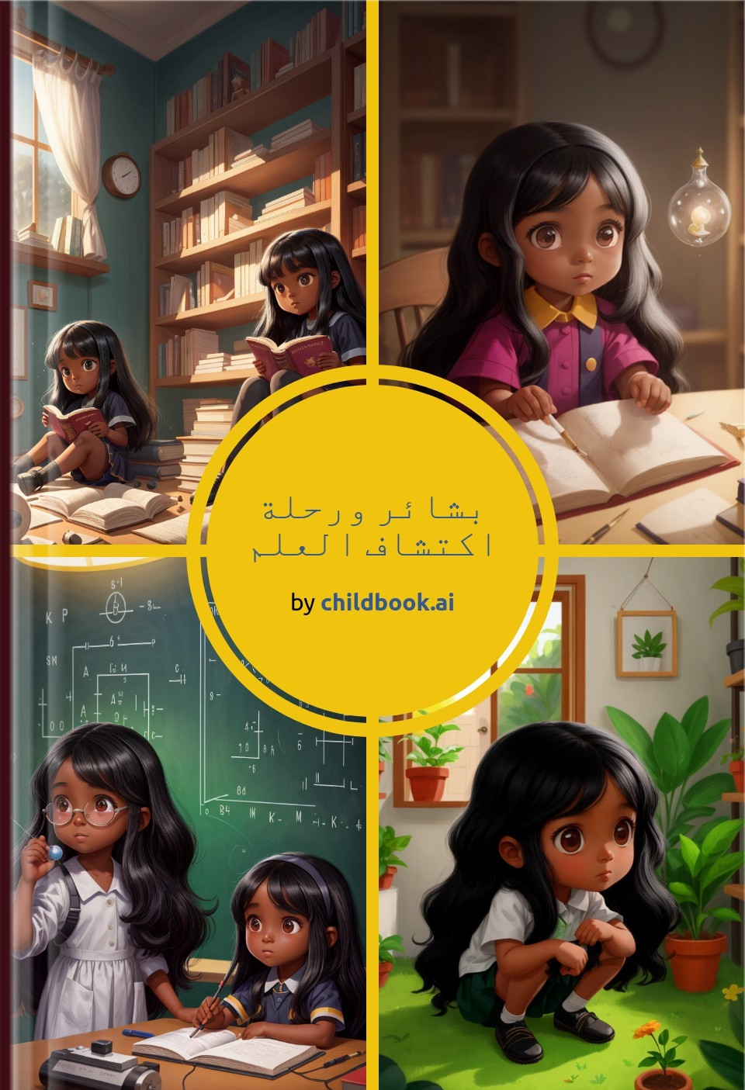

Create a unique children's story with our easy-to-use ai storybook maker. Our personalized children's books are fully customized with original characters, illustrations, and an imaginative plot.